
LARAVEL INVENTORY AND BILLING MANAGEMENT SYSTEM

Technology Stack:
Laravel Framework
PHP
MySQL
HTML
CSS
JavaScript
Project Type:
Business Management Software Application
Date:
2026

Developed By: S.M. Abdul Azoor
Table of Contents
1. INTRODUCTION 2
2. PROJECT BACKGROUND 2
3. PROBLEM STATEMENT 3
4. PROJECT OBJECTIVES 3
5. SYSTEM FEATURES 4
5.1 Product Management Module 4
5.2 Sales Management Module 4
5.3 Inventory Management Module 4
5.4 Invoice Generation Module 4
5.5 Reporting Module 5
6. SYSTEM ARCHITECTURE 5
7. DATABASE DESIGN 6
8. DEVELOPMENT METHODOLOGY 8
9. SYSTEM IMPLEMENTATION 9
10. TESTING AND VALIDATION 10
10.1 Testing Approach 10
10.2 Test Cases 10
10.3 Testing Summary 14
11. SCREENSHOTS OF THE DEVELOPED SYSTEM 14
11.2 Product Management Interface 15
11.3 Product Listing Interface 16
11.4 Edit Product Interface 16
11.5 Sales Creation Interface 17
11.6 Sales History Interface 17
11.7 Inventory Monitoring Interface 18
11.8 Invoice Generation Interface 18
11.9 Database Implementation 19
12. FUTURE ENHANCEMENTS 20
13. CONCLUSION 21
Appendix 1 – Final Github Code 21

Figure 1 Er digram 8
Figure 2 Dashboard Interface 15
Figure 3Product Management Interface 15
Figure 4 Product Listing Interface 16
Figure 5 Edit Product Interface 16
Figure 6 Sales Creation Interface 17
Figure 7 Sales History Interface 17
Figure 8 Inventory Monitoring Interface 18
Figure 9 Invoice Generation Interface 18
Figure 10 Products table php my admin 19
Figure 11 sales table php my admin 19
Figure 12 sale_items table php my admin 20

INTRODUCTION
The Laravel Inventory and Billing Management System is a business software application developed to automate inventory management and sales processing activities within an organization. The system provides an efficient method for managing products, monitoring stock levels, recording sales transactions, and generating invoices.
The project was developed using the Laravel Framework and MySQL database. Laravel follows the Model-View-Controller (MVC) architectural pattern, which promotes organized code structure, maintainability, and scalability.
This application was designed to simulate a real-world business environment where inventory records and billing operations must be managed accurately. Through automation, the system reduces manual effort, minimizes human errors, and improves operational efficiency.

PROJECT BACKGROUND
Many small and medium-sized businesses still depend on manual methods such as notebooks, spreadsheets, or paper-based records to manage inventory and sales transactions. These methods often result in inaccurate stock records, duplicate entries, calculation errors, and difficulties in generating reports.
Modern businesses require efficient software solutions that can manage products, inventory, and billing activities in a centralized environment. Laravel provides a powerful framework for developing such solutions due to its robust architecture, security features, and database management capabilities.
This project was developed to demonstrate the practical implementation of a modern business software solution using Laravel and MySQL technologies.

PROBLEM STATEMENT
Businesses that rely on manual inventory tracking often face several challenges.
• Difficulty monitoring stock availability.
• Errors during sales calculations.
• Inability to generate invoices quickly.
• Lack of centralized record management.
• Poor visibility of sales history.
• Increased risk of inventory inconsistencies.
To overcome these challenges, an automated inventory and billing management system is required.
The proposed system provides an integrated platform for managing products, processing sales transactions, automatically updating stock quantities, and maintaining accurate business records.

PROJECT OBJECTIVES
The primary objective of this project is to develop a Laravel-based Inventory and Billing Management System capable of supporting daily business operations.
Specific objectives include:
• Implement product management functionality.
• Create a sales processing module.
• Automatically update inventory levels after each sale.
• Generate professional invoices.
• Maintain sales history records.
• Provide dashboard-based reporting features.
• Demonstrate practical application of Laravel development concepts.

SYSTEM FEATURES
The Laravel Inventory and Billing Management System consists of several integrated modules that work together to support inventory management and sales operations.

5.1 Product Management Module
The product management module allows users to maintain product information within the system.
Functions:
• Add new products
• Update product details
• Delete products
• View available products
• Manage product pricing
• Monitor inventory quantities

5.2 Sales Management Module
The sales module enables users to record customer purchases and manage sales transactions efficiently.
Functions:
• Create new sales records
• Select products for purchase
• Calculate transaction totals
• Store sales information
• Maintain sales history

5.3 Inventory Management Module
The inventory module automatically updates stock levels whenever a sale is completed.
Functions:
• Stock quantity monitoring
• Automatic stock reduction
• Inventory tracking
• Low stock identification

5.4 Invoice Generation Module
The invoice generation module creates professional invoices for completed sales transactions.
Functions:
• Generate invoices
• Display customer details
• Display purchased products
• Display transaction totals
• Maintain invoice records

5.5 Reporting Module
The reporting module provides useful information regarding inventory and sales performance.
Functions:
• View total sales
• View sales history
• Monitor available inventory
• Identify low-stock products

SYSTEM ARCHITECTURE
The system is developed using the Model-View-Controller (MVC) architectural pattern provided by the Laravel framework. This architecture separates the application into three main layers to ensure clean structure and maintainability.
Model:
Handles database operations and business logic. It interacts directly with MySQL tables such as Products, Sales, and Sale_Items.
View:
Responsible for the user interface. Blade templates are used to display product lists, sales forms, dashboards, and invoices.
Controller:
Handles user requests, processes business logic, and communicates between Models and Views.
Architecture Flow
The system is based on the Model-View-Controller (MVC) architectural pattern, which ensures a clear separation between the user interface, business logic, and database operations.
When a user interacts with the system, a request is first sent through the defined routes in the Laravel framework. These routes act as a bridge between the user interface and the backend logic by directing the request to the appropriate controller.
The controller is responsible for processing the request. It handles business logic such as validating input data, managing sales transactions, updating inventory, and coordinating communication between the model and the view.
The controller interacts with the model layer when database operations are required. The model represents the database structure and is responsible for retrieving, inserting, updating, and deleting data from the MySQL database.
Once the required data is processed, it is passed back to the view layer. The view is responsible for displaying the final output to the user through Blade templates, such as product pages, sales pages, dashboards, and invoices.
Finally, the response is returned to the user in the form of a rendered web page.

Flow Summary
User Request → Routes → Controller → Model → MySQL Database → Model → Controller → View → User Response
This architecture improves maintainability, scalability, code organization, and software quality.
Benefits of MVC Architecture:
• Clear separation of responsibilities
• Improved code maintainability
• Easier debugging and testing
• Better scalability
• Enhanced software structure

DATABASE DESIGN
The database was designed using a relational database structure implemented through MySQL.
The system contains three primary tables.
Products Table
Purpose:
Stores inventory information.
Attributes:
• id
• name
• code
• price
• quantity
• low_stock_limit
• created_at
• updated_at
Sales Table
Purpose:
Stores sales transaction information.
Attributes:
• id
• customer_name
• customer_id
• total_amount
• created_at
• updated_at
Sale_Items Table
Purpose:
Stores individual product details related to each sale.
Attributes:
• id
• sale_id
• product_id
• quantity
• unit_price
• subtotal
• created_at
• updated_at
Entity Relationship Description
One Sale can contain multiple Sale Items.
One Product can appear in multiple Sale Items.
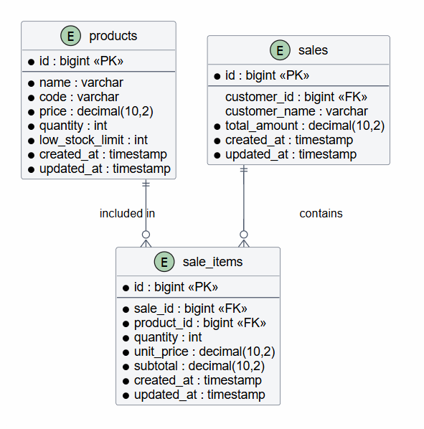
Figure 1 Er digram

DEVELOPMENT METHODOLOGY
The development of this project followed a structured software development approach.
Requirement Analysis
Initially, business requirements were identified. The system needed inventory management, sales processing, invoice generation, and reporting capabilities.
System Design
The database structure, application architecture, and user interfaces were planned before implementation.
Development
Laravel was used to develop the application modules. Models, Controllers, Routes, Migrations, and Views were created according to Laravel development standards.
Database Implementation
MySQL was used to create and manage relational database tables required by the application.
Testing
Functional testing was performed to ensure that each module operated according to requirements.
Deployment Preparation
The completed system was prepared for future deployment and business use.
Advantages of the Development Approach
• Organized project structure
• Easier maintenance
• Better quality control
• Reduced development errors
• Improved scalability

SYSTEM IMPLEMENTATION
The system was implemented using Laravel Framework and MySQL Database.
The implementation process involved configuring the development environment, creating database migrations, developing application models, implementing controllers, designing user interfaces, and integrating business logic.
Key Laravel Components Used
Routes
Routes were used to define URL endpoints and manage user requests.
Controllers
Controllers were implemented to process business logic and coordinate communication between views and models.
Models
Models were used to interact with database tables and manage application data.
Migrations
Migrations were used to create and modify database tables in a structured manner.
Blade Templates
Blade templates were used to develop dynamic and reusable user interfaces.
Business Logic Implemented
• Product CRUD operations
• Sales transaction processing
• Inventory quantity updates
• Sales history management
• Prevention of negative stock values through validation
• Invoice generation
• Reporting functions
The implementation demonstrates practical software engineering concepts including database integration, object-oriented programming, MVC architecture, and business application development.

TESTING AND VALIDATION
Testing is an essential phase of software development that ensures the system functions according to specified requirements. Functional testing was conducted on each module of the application to verify correctness, reliability, and usability.
The objective of testing was to identify defects, validate system behavior, and confirm that all implemented features operated as expected.

10.1 Testing Approach
The testing process focused primarily on functional testing. Each feature was tested individually and then verified as part of the complete system workflow.
The following areas were tested:
• Product management
• Inventory management
• Sales processing
• Database operations
• Invoice generation
• Reporting functions

10.2 Test Cases
Test Case 01
Module:
Product Management
Test Scenario:
Add a new product.
Expected Result:
Product should be saved to the database.
Actual Result:
Product successfully added and displayed in product list.
Status:
Pass

Test Case 02
Module:
Product Management
Test Scenario:
Update existing product information.
Expected Result:
Updated information should be stored in the database.
Actual Result:
Product details updated successfully.
Status:
Pass

Test Case 03
Module:
Product Management
Test Scenario:
Delete an existing product.
Expected Result:
Product should be removed from the database.
Actual Result:
Product successfully deleted.
Status:
Pass

Test Case 04
Module:
Sales Management
Test Scenario:
Create a new sales transaction.
Expected Result:
Sales record should be stored successfully.
Actual Result:
Sale successfully recorded.
Status:
Pass

Test Case 05
Module:
Inventory Management
Test Scenario:
Complete a sale and verify stock reduction.
Expected Result:
Product quantity should automatically decrease.
Actual Result:
Stock quantity updated correctly.
Status:
Pass
Test Case 06
Module:
Sales Management / Inventory Management
Test Scenario:
Attempt to create a sale where requested quantity exceeds available stock.
Expected Result:
System should block the sale and display an error message such as:
“Not enough stock available” or “Product is out of stock”.
Actual Result:
Sale is prevented and user is redirected back without reducing stock.
Status:
Pass

Test Case 07
Module:
Inventory Management
Test Scenario:
Attempt to sell a product when stock quantity is 0.
Expected Result:
System should prevent the sale and display “Out of stock” message.
Actual Result:
System correctly blocks the transaction.
Status:
Pass

Test Case 08
Module:
Invoice Generation
Test Scenario:
Generate invoice after completing a sale.
Expected Result:
Invoice should be created successfully.
Actual Result:
Invoice generated correctly.
Status:
Pass

Test Case 09
Module:
Reporting
Test Scenario:
View sales history.
Expected Result:
System should display all recorded sales.
Actual Result:
Sales history displayed correctly.
Status:
Pass

10.3 Testing Summary
The testing process confirmed that all major modules operated according to requirements. Product management, sales processing, inventory updates, and reporting functionalities were successfully validated.
The application demonstrated stable performance during testing and produced accurate results throughout the evaluation process.

SCREENSHOTS OF THE DEVELOPED SYSTEM
The following screenshots demonstrate the successful implementation of the Laravel Inventory and Billing Management System.
.11.1 Dashboard Interface
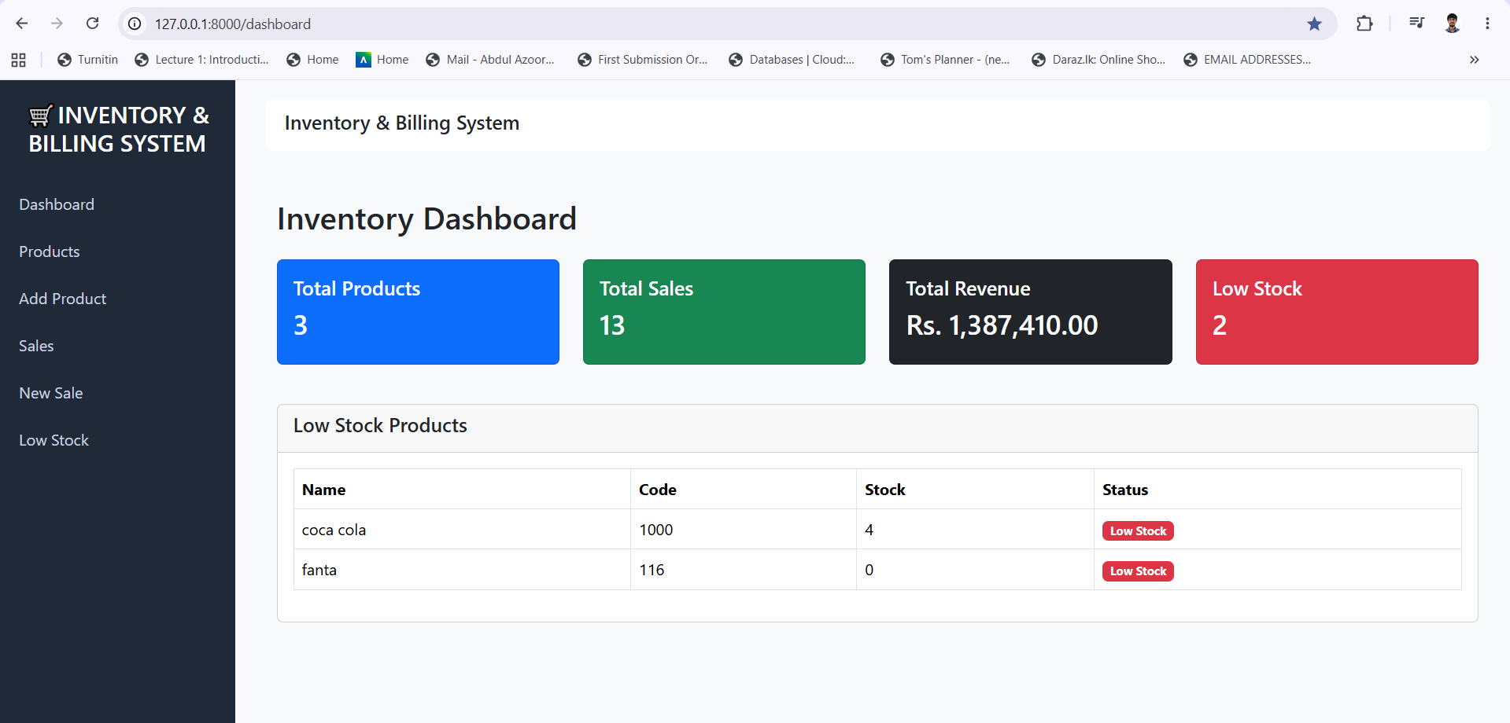
Figure 2 Dashboard Interface
Description:
The dashboard provides an overview of system activities and key business information.

11.2 Product Management Interface
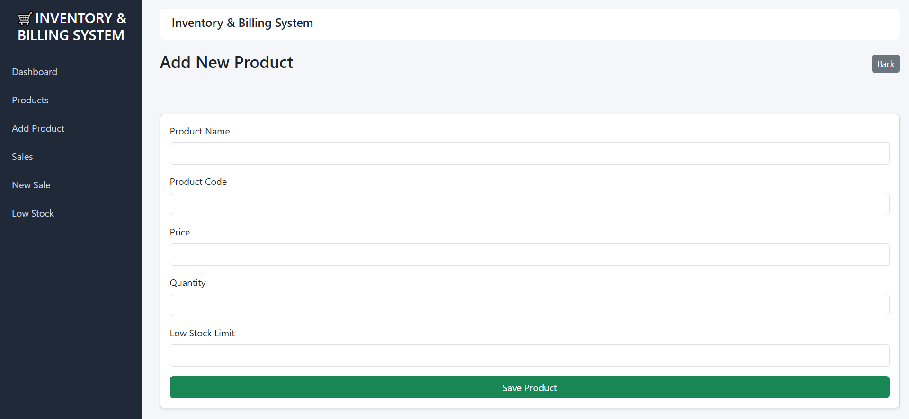
Figure 3Product Management Interface
Description:
Users can create new products and enter inventory information.

11.3 Product Listing Interface
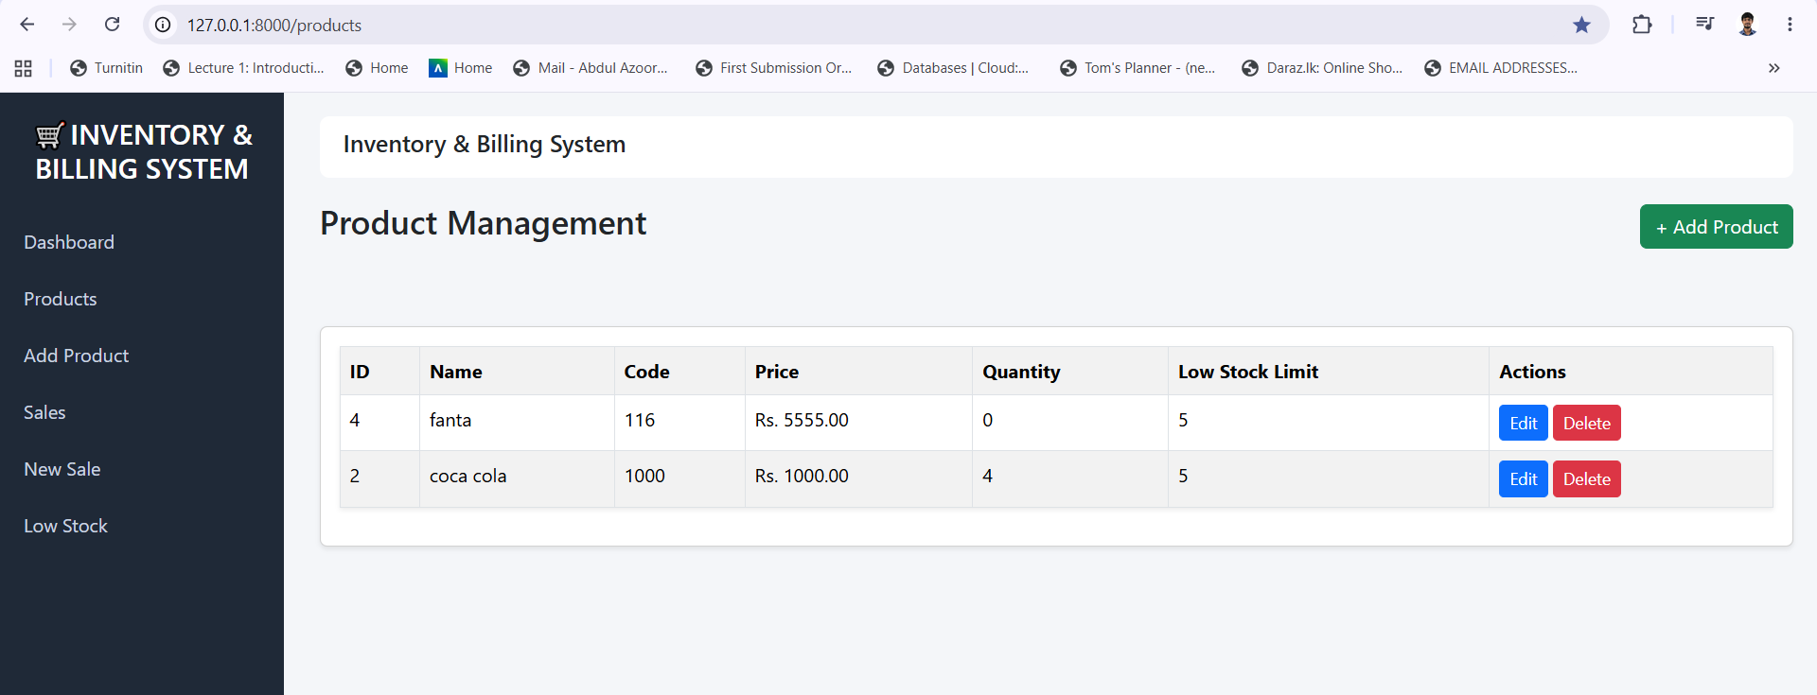
Figure 4 Product Listing Interface
Description:
Displays all available products stored within the system.

11.4 Edit Product Interface
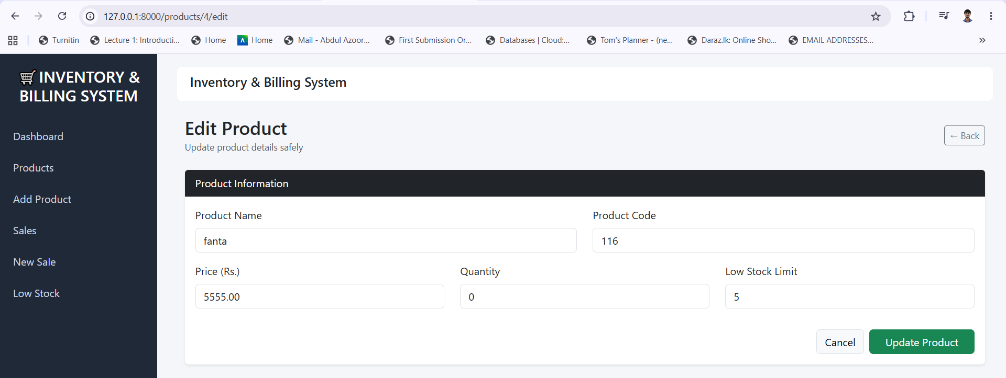
Figure 5 Edit Product Interface
Description:
Allows users to update product information.

11.5 Sales Creation Interface
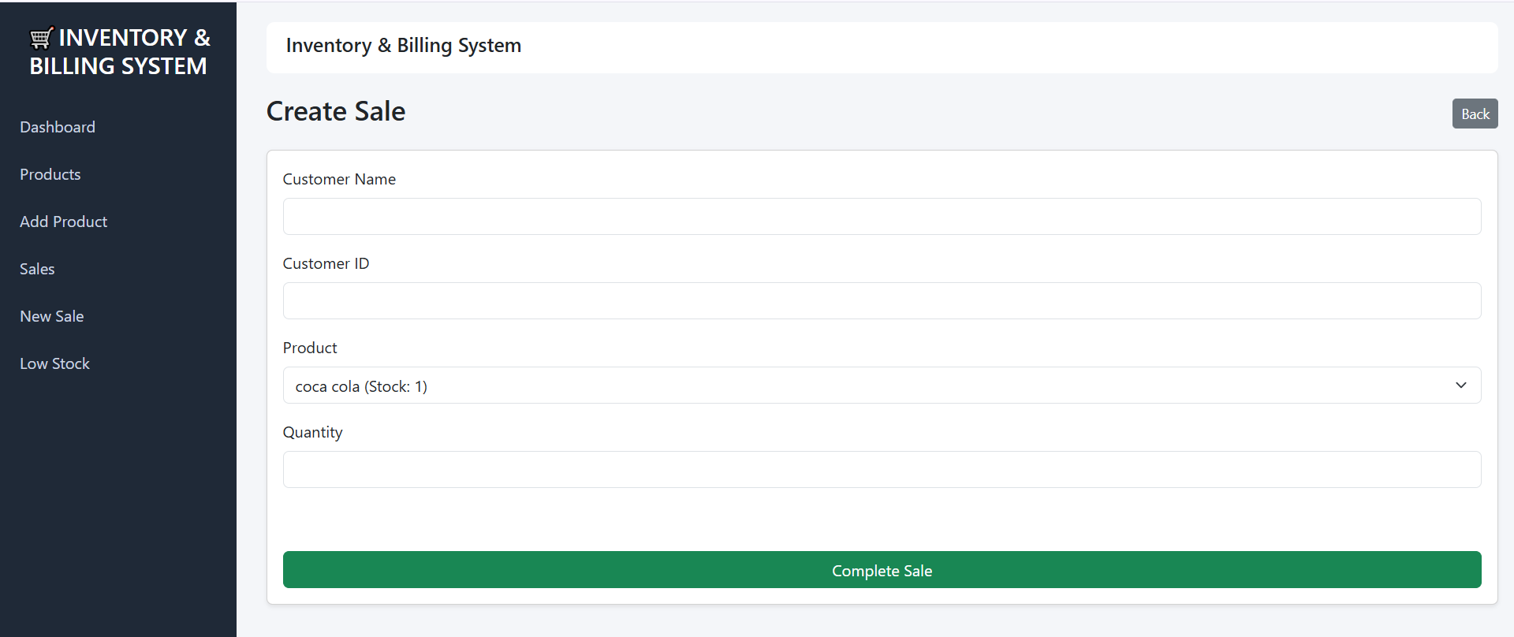
Figure 6 Sales Creation Interface
Description:
Users can record customer purchases and create sales transactions.

11.6 Sales History Interface
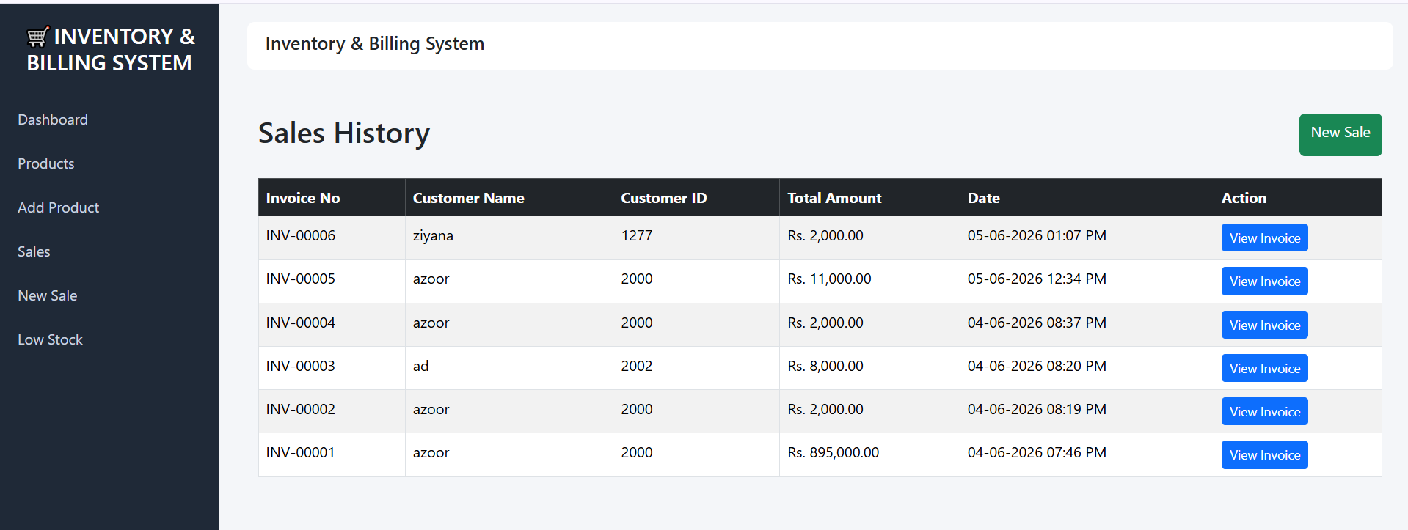
Figure 7 Sales History Interface
Description:
Displays previously recorded sales transactions.

11.7 Inventory Monitoring Interface

Figure 8 Inventory Monitoring Interface
Description:
Demonstrates automatic inventory updates following sales transactions.

11.8 Invoice Generation Interface
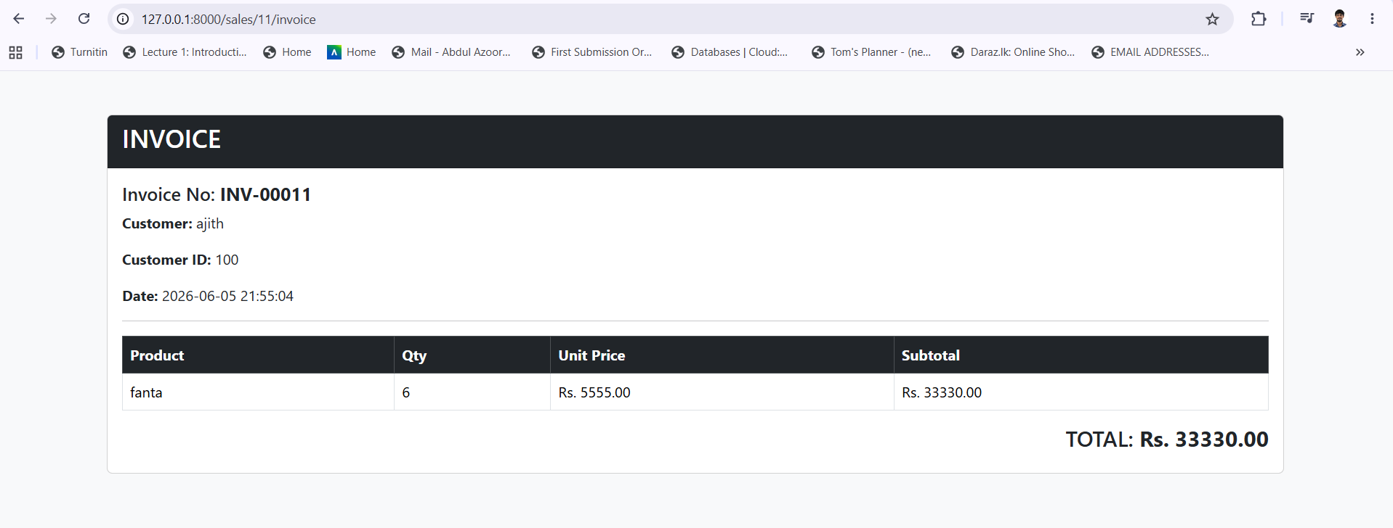
Figure 9 Invoice Generation Interface
Description:
Displays the invoice generated for a completed sales transaction.

11.9 Database Implementation
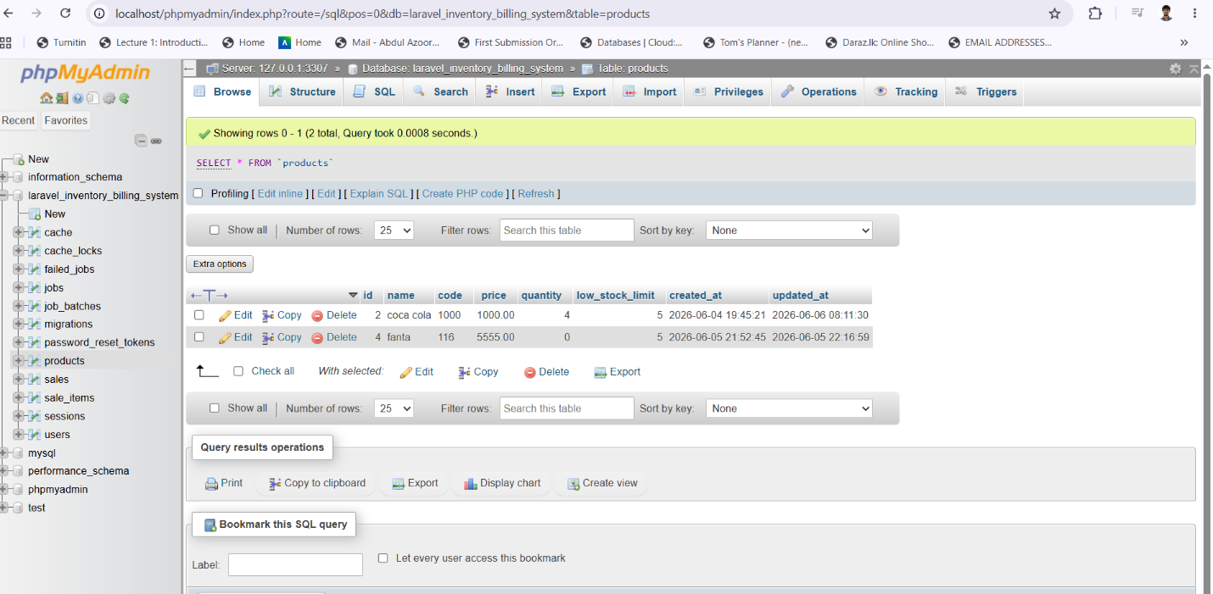
Figure 10 Products table php my admin
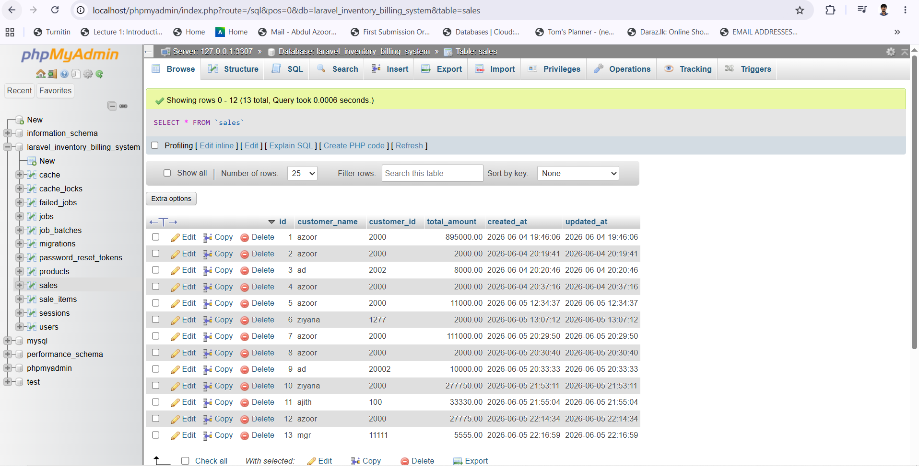
Figure 11 sales table php my admin
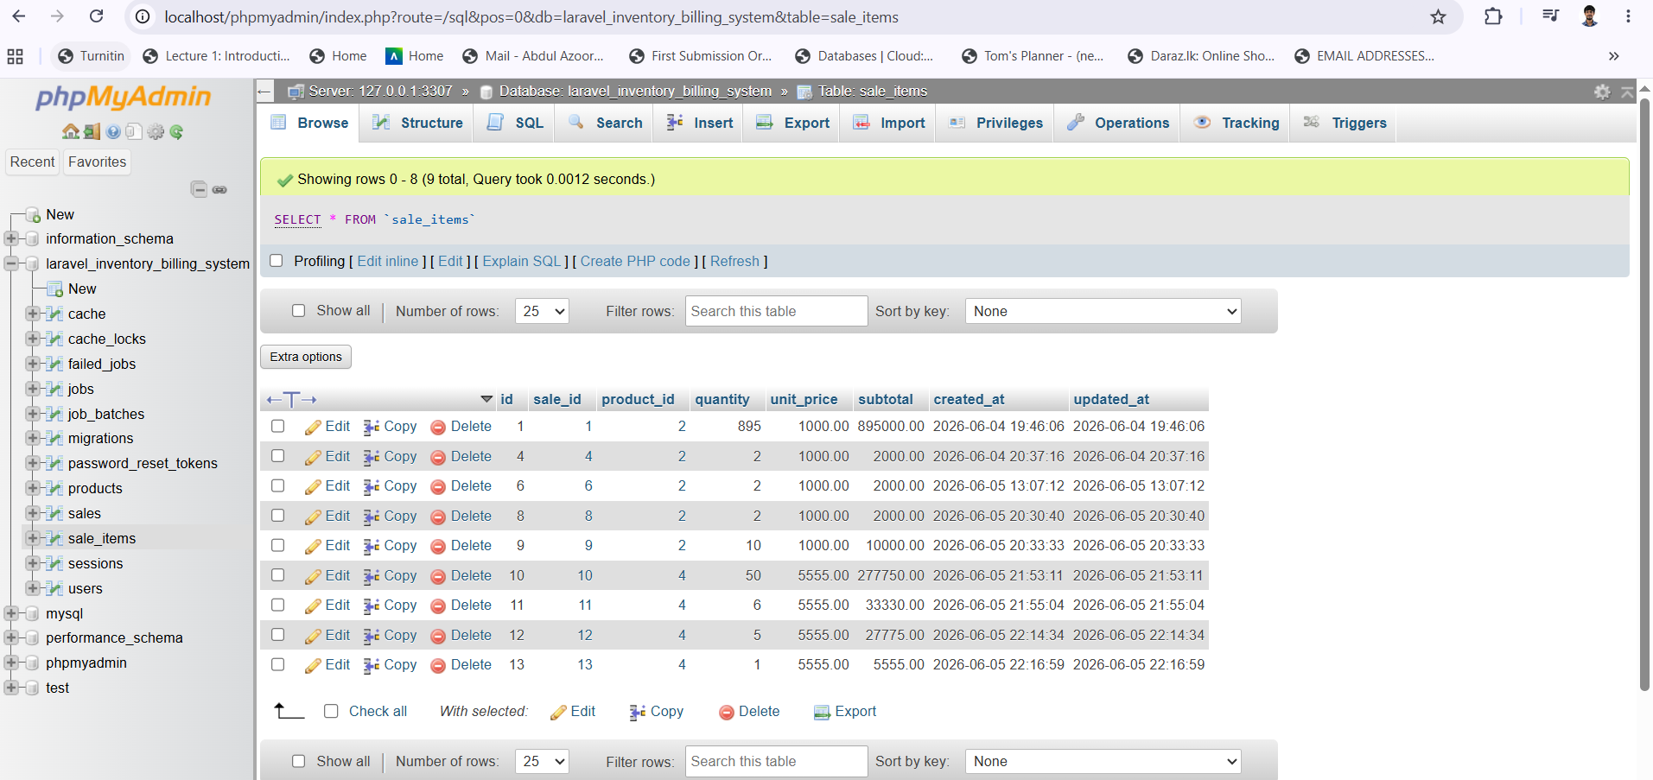
Figure 12 sale_items table php my admin
Description:
Shows successful database implementation and data storage.

FUTURE ENHANCEMENTS
Although the current system successfully meets the identified business requirements, several enhancements can be implemented in future versions.
Potential Future Improvements
• Barcode scanning functionality
• Supplier management module
• Purchase order management
• Multi-user role management
• Email invoice delivery
• SMS notification services
• Advanced business analytics
• Inventory forecasting
• Customer management module
• Cloud deployment
• Mobile application integration
• Real-time dashboard analytics
These enhancements would further improve operational efficiency and expand system capabilities.

CONCLUSION
The Laravel Inventory and Billing Management System was successfully developed to automate inventory management and billing operations. The system provides a centralized platform for managing products, processing sales transactions, maintaining inventory records, and generating invoices.
Throughout the development process, modern software engineering principles and Laravel development practices were applied. The implementation demonstrated practical knowledge of database management, MVC architecture, object-oriented programming, authentication mechanisms, and business application development.
The completed application successfully achieved all identified project objectives. Functional testing confirmed that the system operated reliably and produced accurate results across all major modules.
This project provided valuable hands-on experience in developing real-world business software using Laravel and MySQL technologies. It also strengthened practical skills in software design, development, testing, and database integration.
Overall, the project demonstrates the ability to design and implement a structured business application capable of supporting real organizational requirements while following professional software development standards.

Appendix 1 – Final Github Code
https://github.com/abdulazoor/laravel-inventory-system

